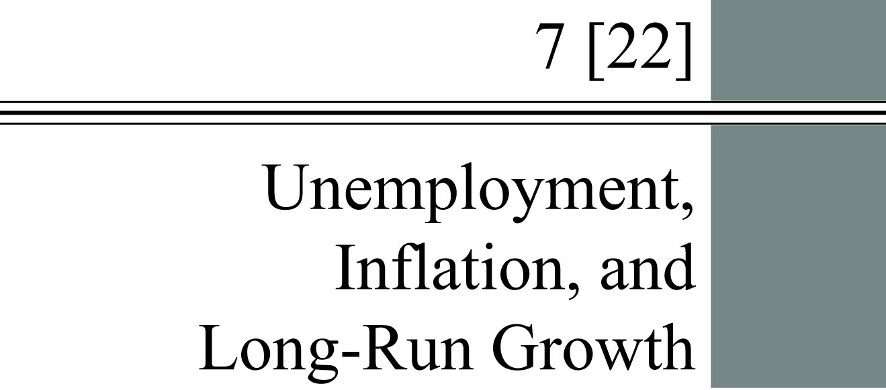

**chapter Outline**

**Unemployment**

Explain how unemployment is measured.

**Inflation and Deflation**

Describe the tools used to measure inflation and discuss the costs and effects of inflation.

**Long-Run Growth**

Discuss the components and implications of long-run growth.

detailed chapter Outline

I. Introduction

Unemployment, inflation, and long-run growth are three key variables used to measure economic well-being.

A. The unemployment rate has information about the state of the labor market.

B. The inflation rate has information about the average price level.

C. The long-run growth rate determines changes in our economic standard of living over long time periods.

1. Much of macroeconomics is concerned with short-run fluctuations called business cycles.

2. Since 1900 the U.S. economy has grown at an average rate of 3.3 percent per year.

II. Unemployment

A. Measuring Unemployment

1. The unemployment statistics released to the press on the first Friday of each month are based on a survey of about 60,000 households conducted by the Bureau of Labor Statistics, a branch of the Department of Labor.

2. An *employed* individual is any person 16 years old or older (1) who works for pay, either for someone else or in his or her own business for 1 or more hours per week, (2) who works without pay for 15 or more hours per week in a family enterprise, or (3) who has a job but has been temporarily absent with or without pay.

3. An *unemployed* individual is someone 16 years old or older who is not working, is available for work, and has made specific efforts to find work during the previous 4 weeks.

4. Someone *not in the labor force* is any person who is not looking for work because he or she does not want a job or has given up looking.

5. The *labor force* is the number of people employed plus the number of unemployed.



6. The *unemployment rate* is the ratio of the number of people unemployed to the total number of people in the labor force.



7. In March 2015, the labor force was 156.906 million people. Of those, 148.331 million were employed, leaving 8.575 million unemployed.



8. The *labor-force participation rate* is the ratio of the labor force to the total population 16 years old or older.



B. Components of the Unemployment Rate

1. By looking at unemployment rates across groups of people, regions, and industries we can better understand the unemployment rate.

2. Unemployment Rates for Different Demographic Groups

a. There are large differences by gender, age, and race.

b. The lowest unemployment rates tend to be among white men and women over the age of 20.

c. The highest unemployment rates tend to be among African-Americans between ages 16 and 19.

3. Discouraged-Worker Effects

a. A discouraged worker is someone who is unemployed but recently stopped looking for work.

b. The *discouraged-worker effect* is the decline in the measured unemployment rate that results when people who want to work but cannot find jobs grow discouraged and stop looking, thus dropping out of the ranks of the unemployed and the labor force.

c. Discouraged workers are not included in the labor force. They are neither employed nor unemployed.

d. In the late stages of a recession the unemployment rate sometimes begins to fall. This decline is not being caused entirely by economic growth increasing. Part of the decrease in the unemployment rate is caused by more discouraged workers.

4. The Duration of Unemployment is the average length of time an unemployed worker is out of work. Unemployment duration tends to increase during recessions. The duration of unemployment following the 2008–2009 recession has remained higher than expected.

D. The Costs of Unemployment

1. Some Unemployment Is Inevitable

a. At any moment there is a group of job seekers and a group of job openings. Matching members of the two groups is time consuming.

b. While job seekers are looking for a job that suits their skills and abilities they are counted as unemployed.

c. Some unemployment is caused by job seekers gathering information about the number and type of jobs available as well as wage rates. This unemployment implies the labor market is working well because workers and jobs will be well matched.

***Economics in Practice: A Quiet Revolution  
Women Join the Labor Force***

Table 7.1 shows that the labor force participation rate in the United States increased from 59.2 percent in 1950 to 62.9 percent in 2014. Much of this increase was due to the increased participation of women in the labor force. In 1955, the labor force participation rate of women was 36 percent. For married women, the rate was even lower at 29 percent. By the 1990s, these numbers shifted considerably. In 1996, the labor force participation rate was 60 percent for all women and 62 percent for married women. The reasons for these changes are complex. Certainly, in the 1960s, there was a change in society’s attitude toward women and paid work. In addition, the baby boom became the baby bust as greater availability of birth control led to fewer births.

Note that the increased opportunity cost of time spent on household activities such as cooking and cleaning led to the rapid growth of two parts of the service sector: housecleaning and restaurant meals.

2. Frictional, Structural, and Cyclical Unemployment

a. *Frictional unemployment* is the portion of unemployment that is due to the normal working of the labor market; used to denote short-run job/skill matching problems. Frictional unemployment is good for the economy because these workers will usually find a job that suits them better (and in which they are likely to be more productive).

b. *Structural unemployment* is the portion of unemployment that is a result of changes in the structure of the economy that result in a significant loss of jobs in certain industries. Structural unemployment creates longer-run adjustment problems that may last for years.

c. The *natural rate of unemployment* is the unemployment rate that occurs as a normal part of the functioning of the economy. Sometimes taken as the sum of the frictional unemployment rate and the structural unemployment rate. Estimates range from 4 percent to 6 percent.

d. *Cyclical unemployment* is unemployment that is above frictional plus structural unemployment. Cyclical unemployment is the increase in unemployment that occurs during recessions and depressions. When the unemployment rate topped 9 percent in the late 2000s, economists were pretty sure that number included some cyclical unemployment.

e. The cost to the economy of cyclical unemployment is the lost GDP. This lost output can never be recovered.

3. Social Consequences of unemployment include economic hardship as well as a number of social and personal ills (anxiety, depression, a deterioration of physical and psychological health, drug abuse, and suicide).

III. Inflation and Deflation

A. Defining Inflation

1. Not all price increases are inflation. Over any time period, prices of some goods will rise and other prices will fall.

2. Inflation is an increase in the overall (average) price level. Deflation is a decrease in the overall (average) price level. Inflation happens when prices of many goods and services increase together.

3. One measure of the average price level is the GDP deflator, discussed in Chapter 21.

B. The Consumer Price Index

1. Price indexes are used to measure average price levels.

2. The *consumer price index (CPI)* is a price index computed each month by the Bureau of Labor Statistics using a bundle that is meant to represent the “market basket” purchased monthly by the typical urban consumer. The CPI is the most commonly quoted price index.

a. The CPI is based on a bundle of goods and services that represent the “market basket” purchased by a typical urban household. The fixed-weight version of the CPI therefore overstates inflation by not allowing substitution.

b. The Bureau of Labor Statistics (BLS) is gradually moving the CPI from a fixed weight index to a chain-weighted index.

c. Even after the calculation methodology is changed the CPI will still cover only prices of consumer goods and it will include import prices (subtracted when calculating the GDP deflator).

d. The CPI “market basket” uses prices from about 71,000 goods and services from 22,000 outlets in 44 geographic areas.

3. *Producer price indexes* (*PPI*)are measures of prices that producers receive for products at various stages in the production process. There are three main PPI categories:

a. finished goods,

b. intermediate materials, and

c. crude materials.

C. The Costs of Inflation

1. Introduction

a. Most people believe inflation makes goods and services more expensive.

b. But this cannot be true for a general inflation. Since households own all the factors of production, an increase in input prices must increase household income by the same percentage.

c. Nominal national income must keep pace with inflation because of the national income accounting identity. Since national income equals national product, inflation must affect income in the same way it affects nominal GDP.

2. Inflation May Change the Distribution of Income

a. Contrary to popular opinion, general inflation does not lower purchasing power because nominal income keeps pace with the average price level.

b. Inflation changes the distribution of income. Some groups may be hurt more than others.

c. Some workers have contracts that automatically increase their wage rate to compensate for increases in the price level. These cost of living adjustment (COLA) clauses protect those workers against inflation—at least for the duration of their contract.

d. Anticipated inflation causes few problems. Unanticipated inflation is largely responsible for the negative effects outlined here. When inflation is high and variable, there is an incentive to try to forecast inflation and buy securities based on these forecasts. Guessing at the inflation rate is not a productive use of resources.

e. If inflation is unanticipated net creditors lose and net debtors gain. In most developed economies, households are net creditors and businesses are net borrowers.

f. If inflation is anticipated it will be incorporated into the nominal interest rate through the Fisher equation (*i* = *r* + *p*e). The *real interest rate* is the difference between the interest rate on a loan and the inflation rate. The real interest rate measures the net transfer of purchasing power, usually from borrowers to lenders.

3. Administrative Costs and Inefficiencies include changing price tags, more frequent bank transactions. Some economists call these menu costs because restaurants have to print new menus to raise prices.

D. What about Deflation?

1. Many governments have begun to worry about deflation.

2. One potential issue is unanticipated deflation. Purchasing power would be transferred from lenders to borrowers.

3. Deflation may also be a signal that aggregate demand is too low to support full employment.

IV. Long-Run Growth

A. Introduction

1. *Output growth* is the growth rate of the output of the entire economy.

2. *Per capita output growth* is the growth rate of output per person in the economy.

3. *Productivity growth* is the growth rate of output per worker.

B. Output and Productivity Growth

1. Since 1900 the U.S. economy has grown 3.2 percent per year on average. Why 3.2 percent? Why not 2 percent or 4 percent? And will such a small difference in growth rates matter?

2. Output can increase if there is an increase in labor or capital or if there is an increase in the amount of time labor and capital are working per week. Capital is anything that is produced that is then used as an input to produce other goods and services.

3. Another way for output to increase is if the quality of the workers increases (*human capital*) or if the quality of the machines increases (*technological improvement*).

4. *Labor productivity* is total output (real GDP) divided by total worker hours (output per worker hour).

5. The long-run upward trend in U.S. productivity (Figure 22.2) has been due to:

a. increases in the amount of capital per worker and

b. improvements in the quality of both workers and machines.

6. Why did productivity growth slow in the 1970s and 1980s, then speed up again in the 1990s? In recent years U.S. productivity growth has slowed again. The best answer economists have is variations in the rate of technological improvement.